Git-HOL Exercise-4:
-Start from a clean main
-Create branch GitWork and add hello.xml
-Switch to main and add a different hello.xml
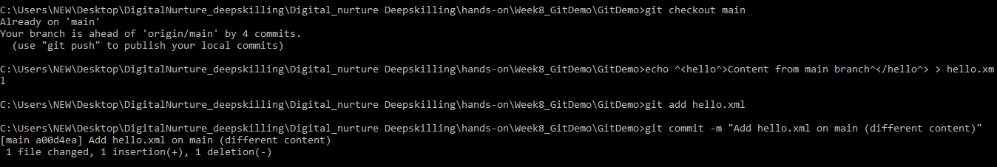
-Inspect history and differences
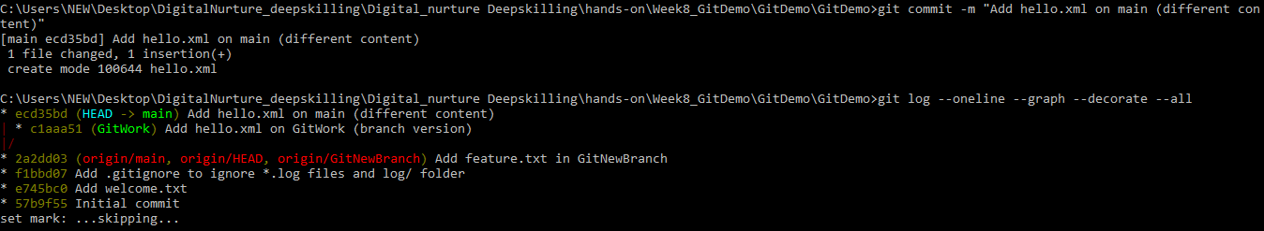
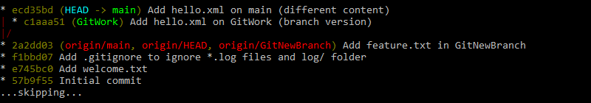
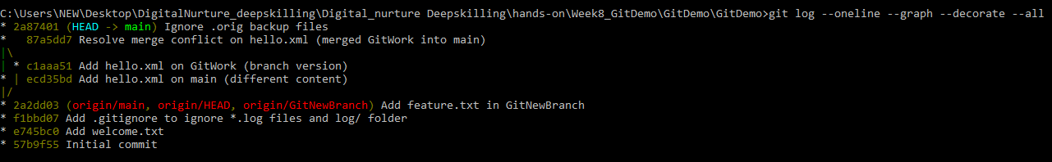
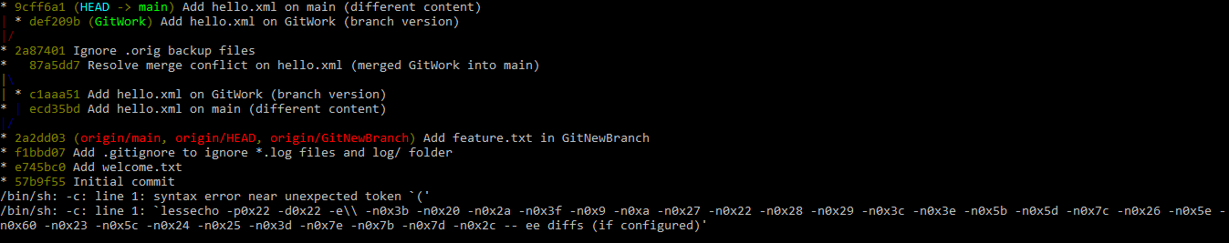
-Merge GitWork into main(this will create a conflict on hello.xml)
-Resolve conflict with P4Merge
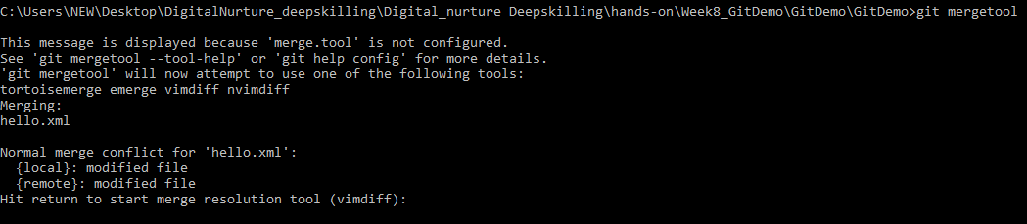
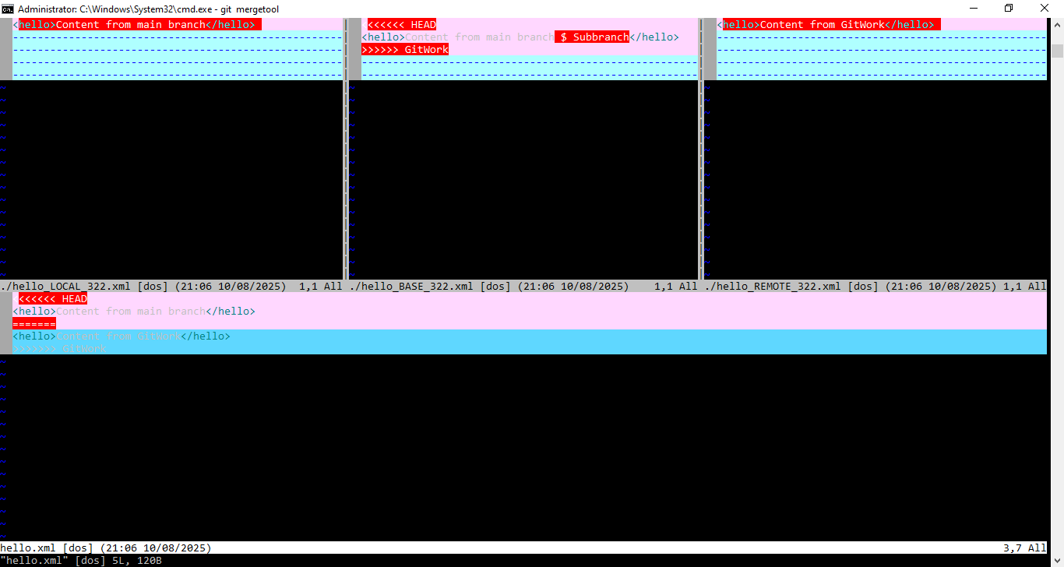
-After closing P4MERGE:
-Add backup or temp files to .gitignore:
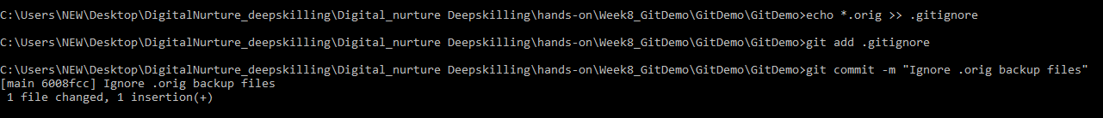
-After Conflict resolution Push GitWork branch:
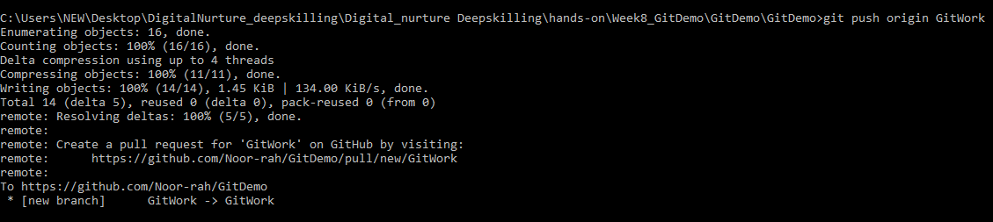
OUTPUT:
All the Branches :
